Name: Hamdy Ahmed Elsherbiny Ahmed

Section 3

Quiz 2

**Q1: Calculate** **the time for each process, define the priority?**

**Answer :**

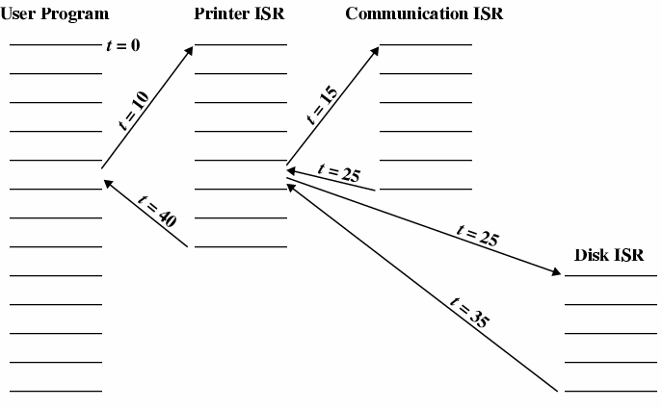

**1**

**2**

**3**

**4**

**5**

**6**

**\* The time for each process is:**

**-User program : t=10**

**-Printer ISR : t=10**

**-Communication ISR : t=10**

**-Disk ISR : t=10**

**--------------------------------------------------------------------**